**Vishnu Badam**

**Sr. Data Engineer**

+1 (469) 907-4193 | [vishnubadam.c@gmail.com](mailto:vishnubadm.c@gmail.com) | [Linkedin.com/in/vishnub](https://www.linkedin.com/in/vishnu-b-318207295/)

**CERTIFICATIONS**

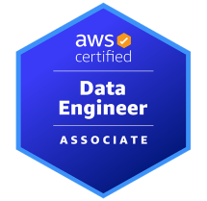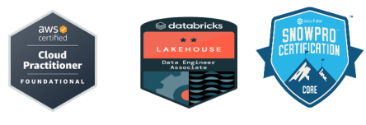

* **Databricks Certified Data Engineer Professional**
* **SnowPro Core Certification**(Snowflake)
* **AWS Certified Data Engineer Associate**

**PROFESSIONAL PROFILE**

{% for k in PROFILE %}

* {{r k }} {% endfor %}

**TECHNICAL SKILLS**

|  |  |
| --- | --- |
| {%tr for category in TECHNICAL_SKILLS %} |  |
| **{{ category.NAME }}** | {{ category.SKILLS }} |
| {%tr endfor %} |  |

**PROFESSIONAL EXPERIENCE**

**Client: UPMC | Pittsburgh, Pennsylvania**

**Role:** Senior Data Engineer **February 2023– Present**  
Project Name :Microsoft Clinical Analytics Modernization (Cloud Analytics Platform)

### **Key Contributions-**

{% for k in KEY_CONTRIBUTION_UP %}

* {{r k }} {% endfor %}

Technologies:{{Technologies_UP}}

**Client: Fidelity | Boston, MA**

**Role:** Senior Data Engineer **December 2020 – Jan 2023**

### **Key Contributions-**

{% for k in KEY_CONTRIBUTION_FI %}

* {{r k }} {% endfor %}

Technologies:{{Technologies_FI}}

**Client: State of Michigan | Lansing, MI**

**Role:** Data Engineer II **December 2018 – May 2020**

### **Key Contributions-**

{% for k in KEY_CONTRIBUTION_MI %}

* {{r k }} {% endfor %}

Technologies:{{Technologies_MI}}

**Client:Lowe's Companies, Inc. logo| Austin, TX**

**Role:** DATA MODELLER **Sep 2017 – Oct 2018**

### **Key Contributions-**

{% for k in KEY_CONTRIBUTION_LO %}

* {{r k }} {% endfor %}

Technologies:{{Technologies_LO}}

**Client: AT&T | New Delhi/NCR region**

**Role:** Junior Data Engineer (Full Time) **Jun 2014 – July 2016**

### **Key Contributions-**

{% for k in KEY_CONTRIBUTION_AT %}

* {{r k }} {% endfor %}

Technologies:{{Technologies_AT}}

**EDUCATION**

* **Master of Science in Data Science (Aug 2016 - Jan 2018) - Bellevue University**
* **Bachelors of Science in Computer Science (Aug 2009 - Jan 2013) - JNTU University**